Student Tapas Kumar Mahanandia

**ASSIGNMENT HYPOTHESE MODULE -5**

1.A F&B manager wants to determine whether there is any significant difference in the diameter of the cutlet between two units. A randomly selected sample of cutlets was collected from both units and measured? Analyze the data and draw inferences at 5% significance level. Please state the assumptions and tests that you carried out to check validity of the assumptions.

File : **Cutlets.csv**

Ho: there is no difference in the diameter of the cutlet between two units

H1: there is a difference between diameter of the cutlet between two units

R.code View Code will be in Zip or Rar file

P:value is 0.2926 p high Null fly , Null Hypothesis Accepted

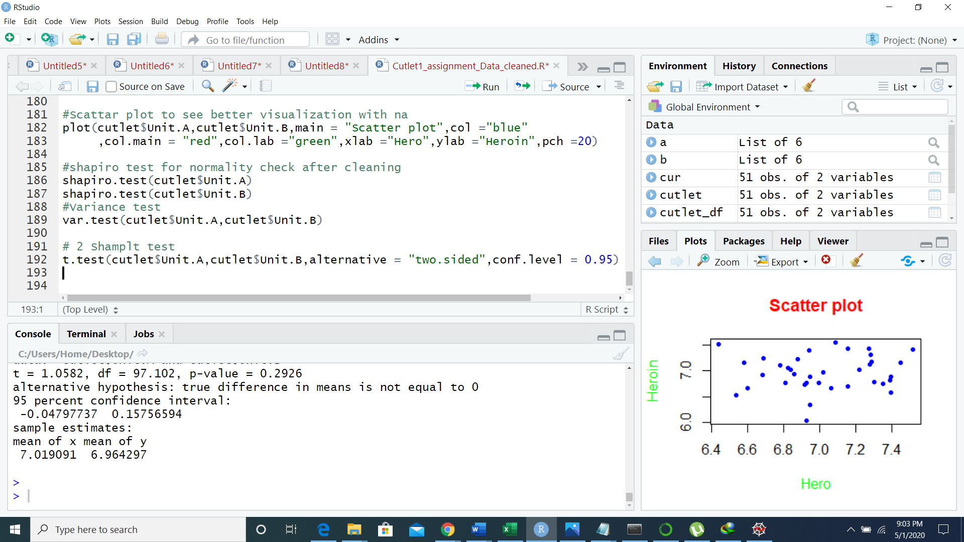

Python code

P:value 0.2925 ,hence p-high Null Fly , Null Hypothesis accepted

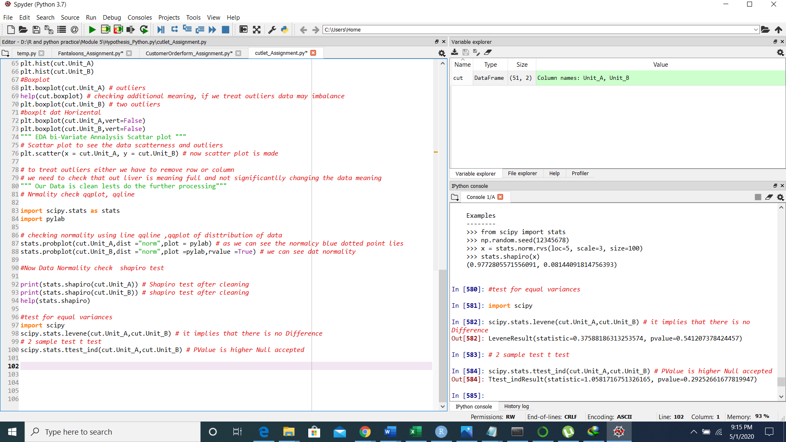

2. A hospital wants to determine whether there is any difference in the average Turn Around Time (TAT) of reports of the laboratories on their preferred list. They collected a random sample and recorded TAT for reports of 4 laboratories. TAT is defined as sample collected to report dispatch.

Analyze the data and determine whether there is any difference in average TAT among the different laboratories at 5% significance level.

File: **LabTAT.csv**

Rcode and Python:

Anova : P-value : 164.1 <2e-16 ***

Ho: is there any significant difference between TAT among different labs

H1: there is no significant difference between TAT among different labs

There is a significant difference H:1 Alternative Accepted

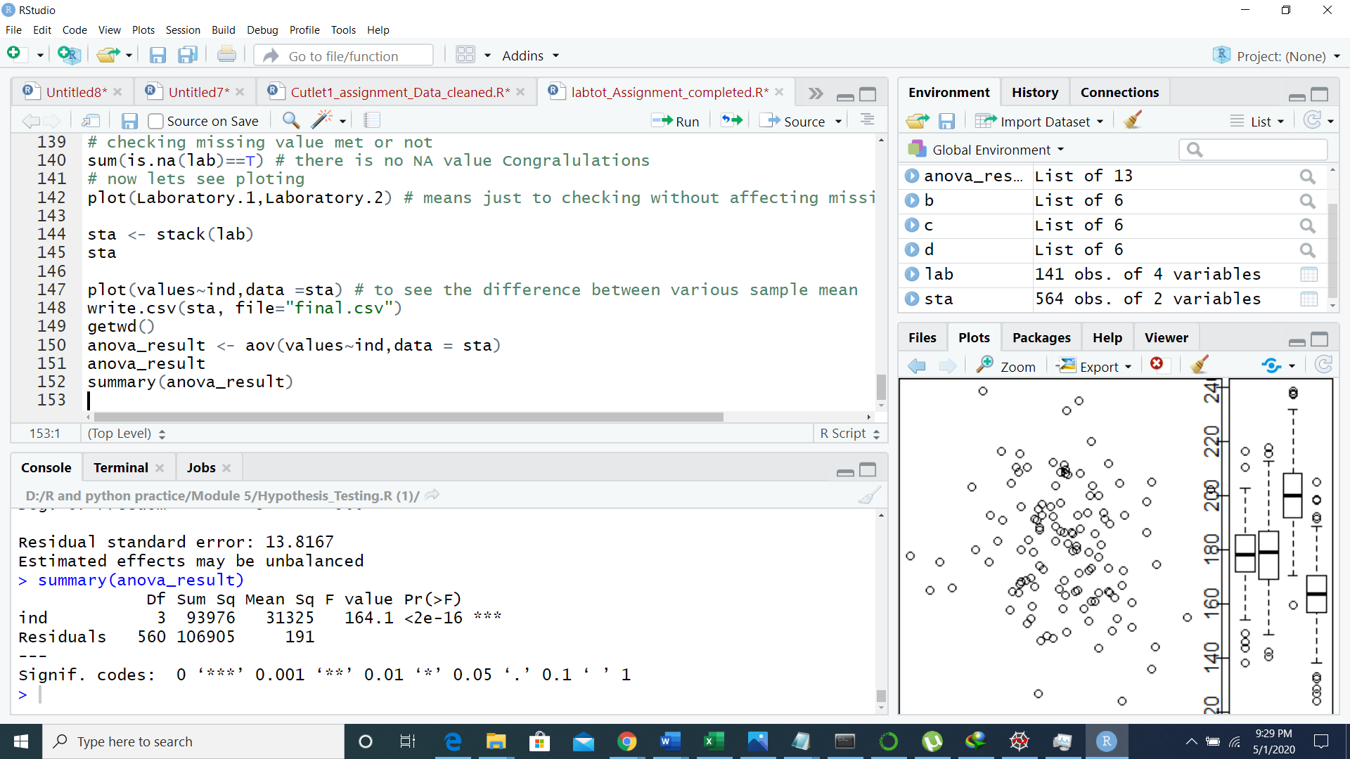

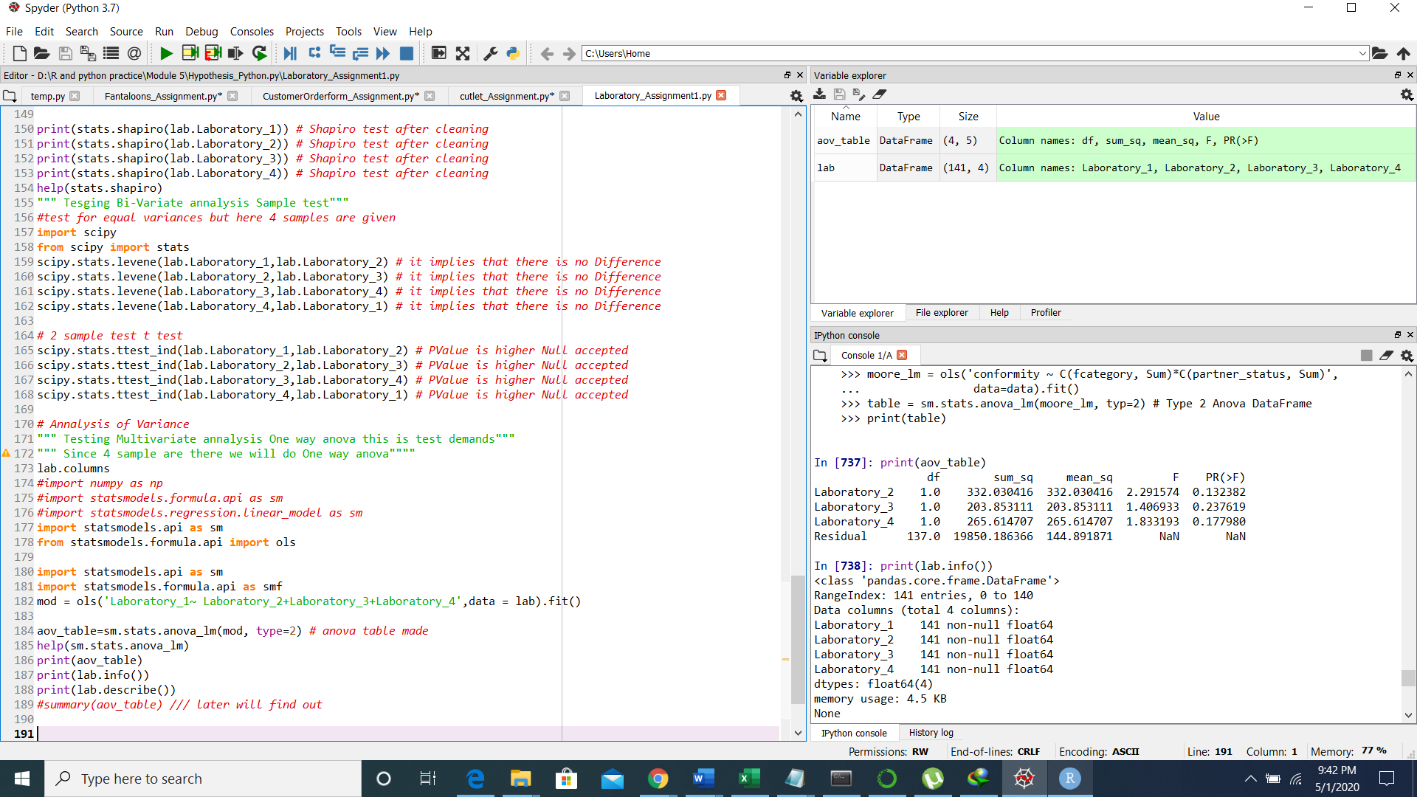

3. Sales of products in four different regions is tabulated for males and females. Find if male-female buyer rations are similar across regions.



H0

* All proportions are equal

Ha

* Not all Proportions are equal

1. Check p-value
2. If p-Value < alpha, we reject Null Hypothesis



Buyer Ratio.csv

|  |  |  |  |  |
| --- | --- | --- | --- | --- |
|  | **East** | **West** | **North** | **South** |
| Males | 50 | 142 | 131 | 70 |
| Females | 550 | 351 | 480 | 350 |

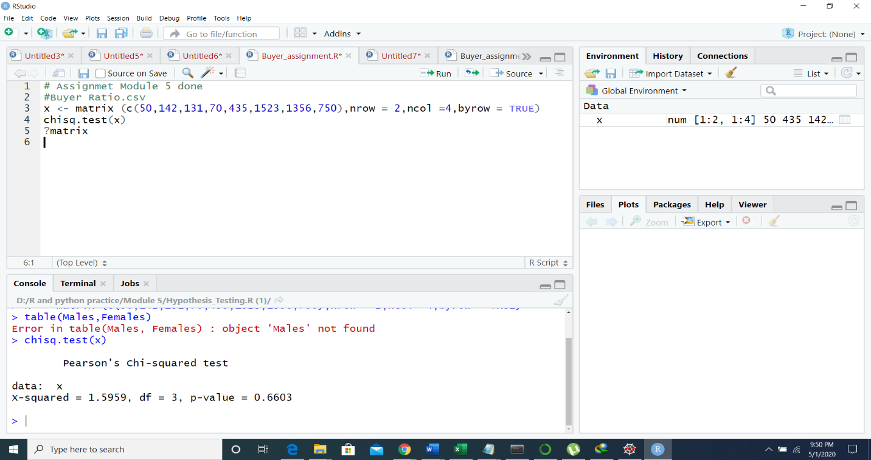

Ho: Sales of the product Different region across similar

H1: Sales of the product Different region in not similar

Rcode: P:value 0.6603 is means p value high Null Hypothesis Accepted.

Means product across different region is similar

Python independent table chi-squared test

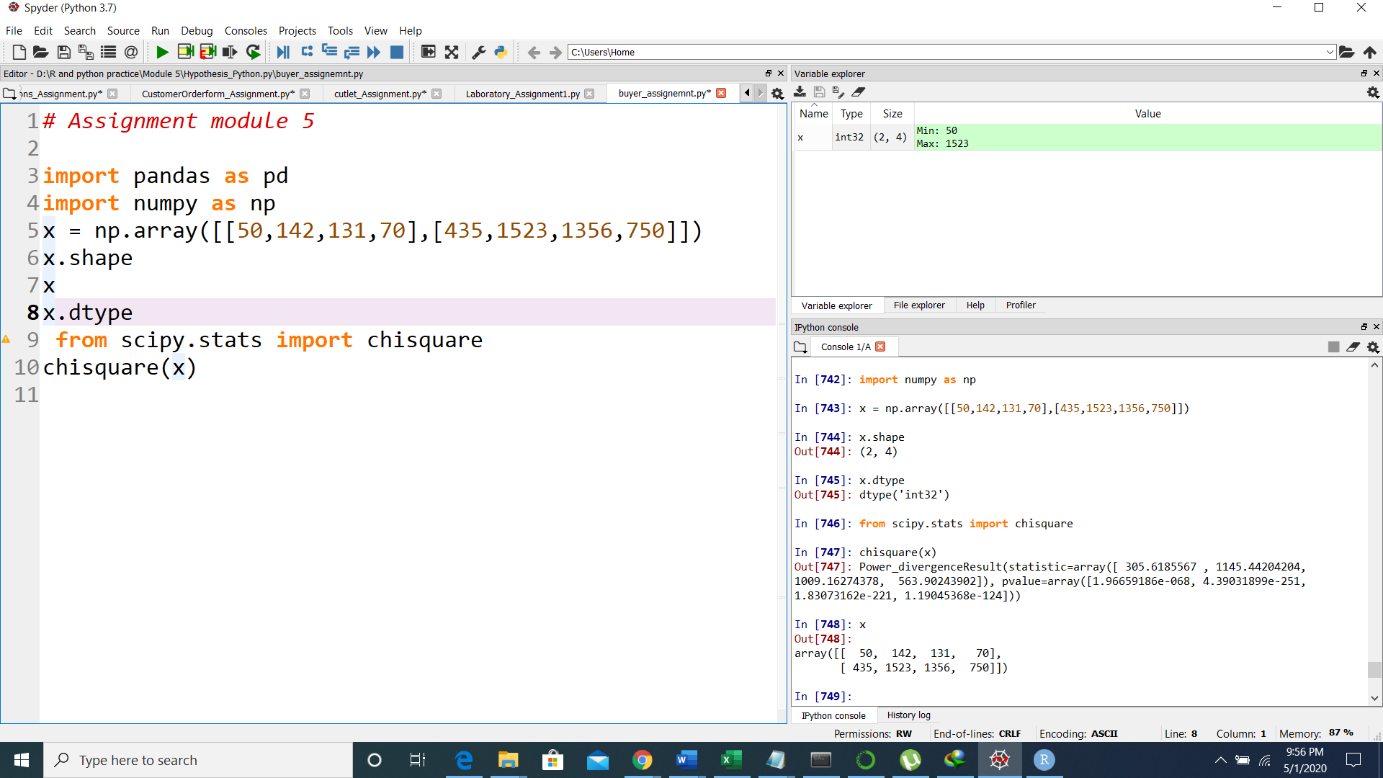

4.Telecall uses 4 centers around the globe to process customer order forms. They audit a certain %of the customer order forms. Any error in order form renders it defective and must be reworked before processing. The manager wants to check whether the defective % varies by center. Please analyze the data at *5%* significance level and help the manager draw appropriate inferences

File: **Customer OrderForm.csv**

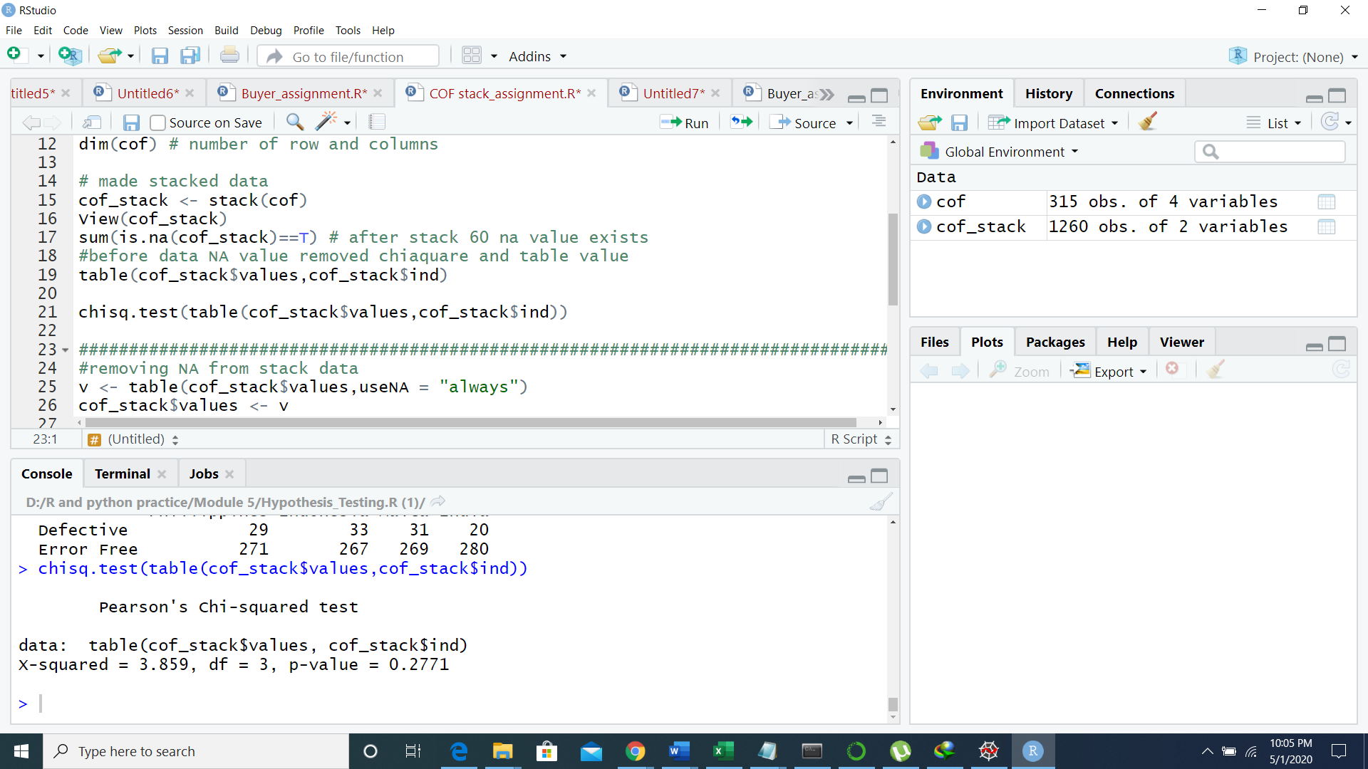

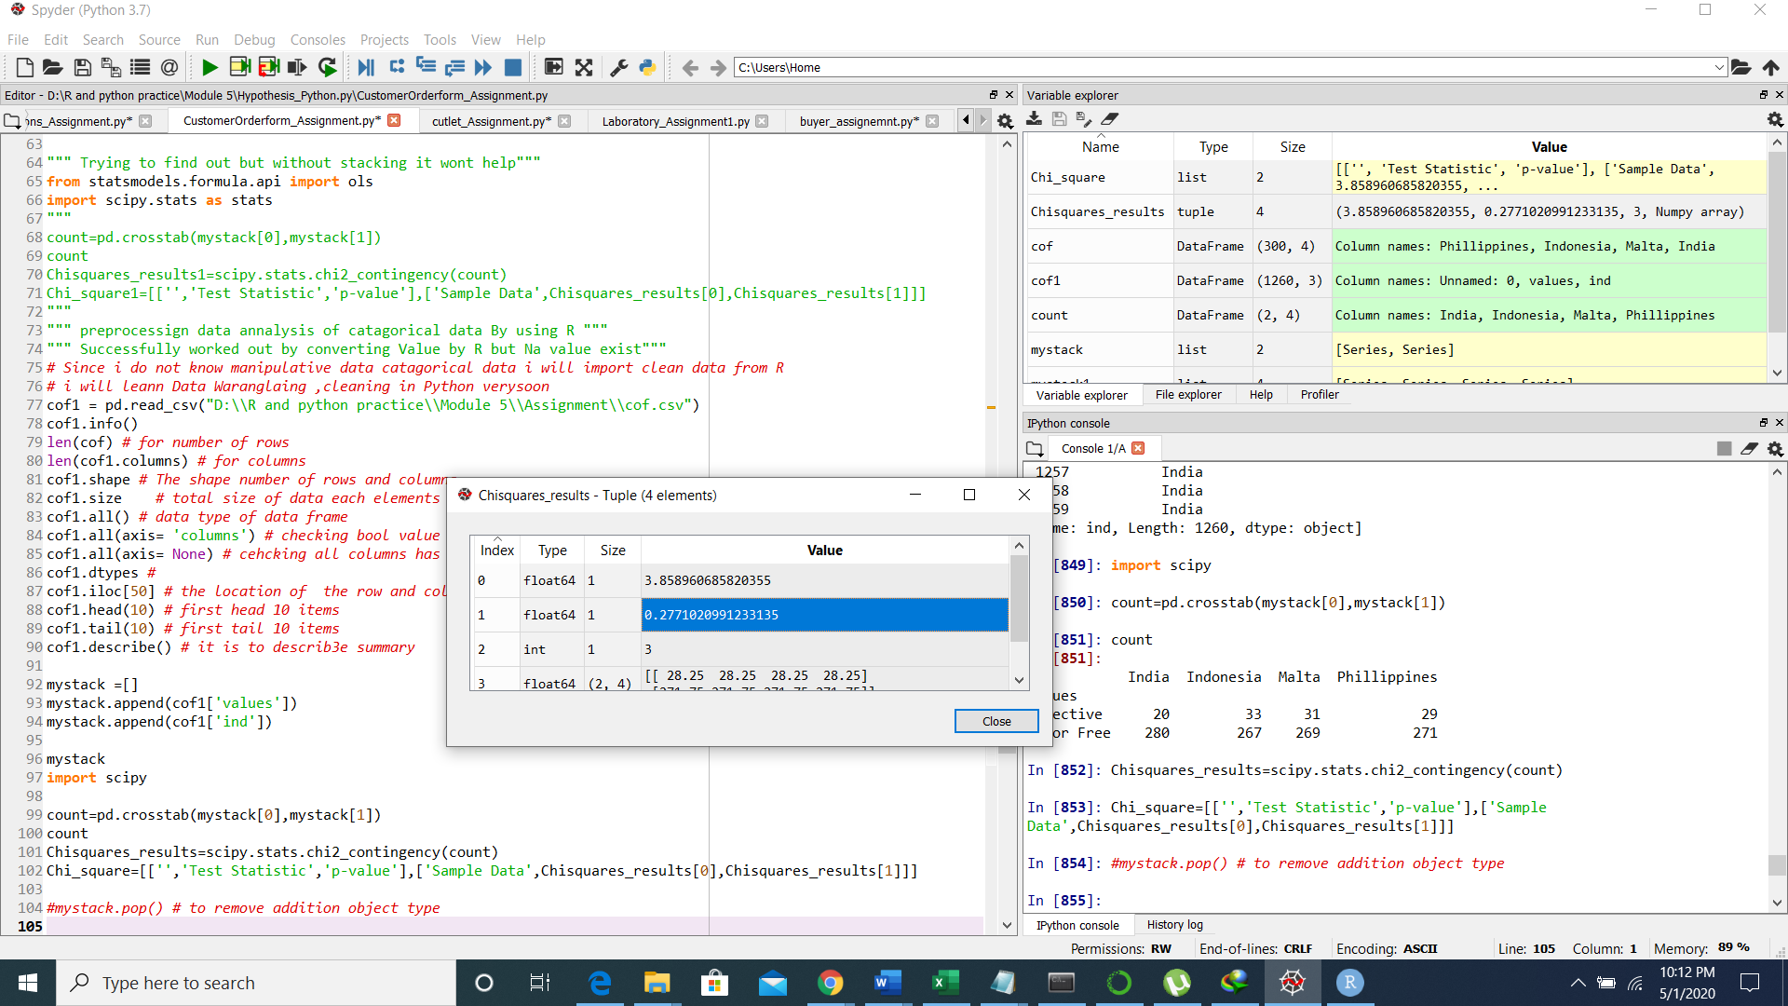

Ho: There is a no significant difference between each centers for diffective

H1: There is a significant Difference between each centers for diffective

P:value is 0.2771 Null hypothesis is accepted

5. Fantaloons Sales managers commented that *%* of males versus females walking into the store differ based on day of the week. Analyze the data and determine whether there is evidence at *5 %* significance level to support this hypothesis.

File: **Fantaloons.csv**

The p-value Explains there is significant difference exist

Null rejected , Alternative Accepted

